Social Security Administration
714 N. Iron Bridge Way, Suite 100
Spokane, WA 99202
To: Social Security Administration Official
STUDENT NAME (as listed in your passport) is a full-time F-1 visa student who is permitted to work on campus at Whitworth University. On-campus employment is limited to 20 hours per week while school is in session, and can be full-time, up to 40 hours per week, during official school break periods.
STUDENT NAME (as listed in your passport has been hired by Whitworth University to work for DEPARTMENT/OFFICE NAME in the position of POSITION TITLE with a start date of DATE.
Employment details
NAME OF SUPERVISOR, SUPERVISOR’S TITLE
NAME OF DEPARTMENT/OFFICE
SUPERVISOR’S WHITWORTH PHONE NUMBER
________________________________________________
(Signature of Whitworth Supervisor endorsing employment)
[Whitworth University EIN#: 91-0473310]
Thank you for your support with this student’s SSN application.
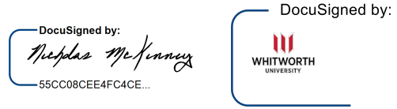
Regards,

Nicholas McKinney
Designated School Official (DSO)
Office of International Education | Whitworth University
300 W. Hawthorne Road | Spokane, WA 99251
nmckinney@whitworth.edu | 509.777.4596

OFFICE OF INTERNATIONAL EDUCATION
Whitworth University | 300 W. Hawthorne Road | Spokane, WA 99251

