AUTHORIZED PERSONNEL ONLY
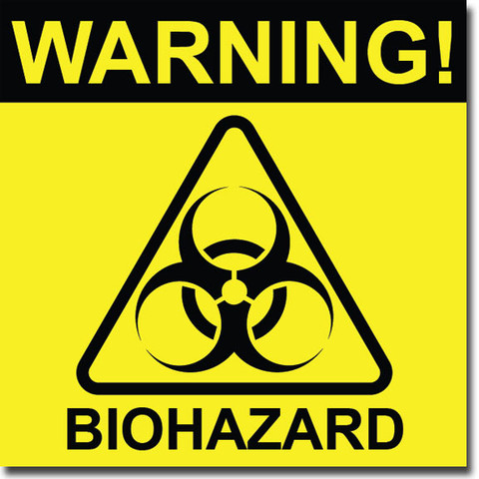
BIOSAFETY LEVEL 2
PRINCIPAL INVESTIGATOR: _____________________________________________
CONTACT INFO: _________________________________________________
LAB MANAGER: _________________________________________________
CONTACT INFO: _________________________________________________
PPE REQUIRED IN THIS LAB: LAB COAT, SPLASH GOGGLES, GLOVES
ENTERING LAB: NO ADDITIONAL REQUIREMENTS BEYOND STANDARD LABORATORY PROCEDURES OUTLINED IN THE ACADEMIC CHEMICAL MANAGEMENT AND SAFETY PROGRAM. ALL APPROPRIATE PPE MUST BE DONNED PRIOR TO CONDUCTING WORK IN THIS LAB. NO FOOD OR DRINK ALLOWED.
IMMUNOCOMPROMISED PERSONNEL MAY BE AT INCREASED RISK DUE TO EXPOSURE TO PATHOGENIC ORGANISMS. IF YOU ARE IMMUNOCOMPROMISED OR THINK YOU MAY BE, PLEASE CONSULT WITH YOUR PHYSICIAN TO ENSURE THAT IT IS SAFE FOR YOU TO ENTER AND WORK WITHIN THIS AREA.
EXITING LAB: CLEAN UP AND PROPERLY STORE ALL EQUIPMENT, CHEMICALS AND SAMPLES. PLACE ALL WASTE IN THE APPROPRIATE AND DISIGNATED COLLECTION CONTAINERS. HANDS MUST BE WASHED BEFORE LEAVING LAB.

